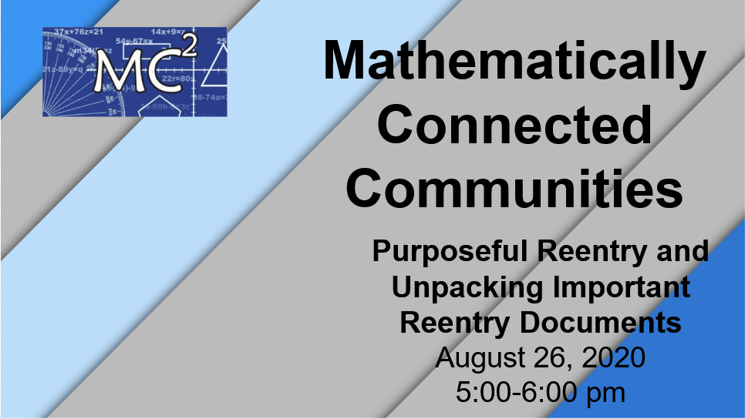
Please note, this is a shared document and many of these links are shared documents. To edit or make changes, please make a copy of this page or a specific resource or download it into a program of your choice. See the second page with instructions on how to do this.

Link to Slideshow: Participant Slides Purposeful Reentry Session 2

Session Specific Links/Additional Resources and Links
Link to Math Team Builder Slides for Break Out Rooms, Slides 6-7: https://docs.google.com/presentation/d/1j9DBlwnB_q3uXD6UjybZI6Nsd8Tx-3qAG_WwL6m2c3Y/edit?usp=sharing
Link to Dan Meyer Card Sort: https://teacher.desmos.com/activitybuilder/custom/5ec598c4ddc3c901dfc053ca
Link to Dan Meyer’s Blog posting about tech impact card sort: https://blog.mrmeyer.com/2020/05/
Link to Dan Meyer’s Blog posting about modeling generosity with mathematics: https://blog.mrmeyer.com/category/3acts/
Scavenger Hunt
Link to Scavenger Hunt, Slide 8: https://docs.google.com/document/d/1lREOUTft-PcsmAIy3JN6r3_kg4FxQvoOmNsNHC_3bjo/edit?usp=sharing
Link for Grade Level Break Out Rooms, Slide 10: https://docs.google.com/presentation/d/1_oJUvhMiZXBLQdIBnC-hgYMNKjwnl0fl0Y71c0pN9Uw/edit?usp=sharing
LINK:K-8: Reentry Guidance Tool, Step 3
LINK: HS: 2020–21 Support for Instructional Content Prioritization in High School Mathematics, Achieve the Core, pp. 13-14

Link to Participants copy NM PED Reentry Guidance: https://docs.google.com/document/d/1LVxA3--C5P3ogO6oN-FGgJeGfhS_ar8D1n72ol-Gnhg/edit?usp=sharing

Link to Desmos Temperature Check, How are you feeling from two weeks ago to now?: https://student.desmos.com/join/x22772

Link to NM PED Website: https://webnew.ped.state.nm.us/
Link to Achieve the Core Priority Instructional Content for both Math/ELA K-8 and HS: https://achievethecore.org/page/3267/2020-21-priority-instructional-content-in-english-language-arts-literacy-and-mathematics

Link to MC² Website: https://mc2.nmsu.edu/
Link to MC² Professional Learning: https://mc2.nmsu.edu/pd/
Link to MC² Contact Page: https://mc2.nmsu.edu/about-us/contact-us/

Thank you for your work and dedication to New Mexico students and families!

Make a Copy or Download a Shared File

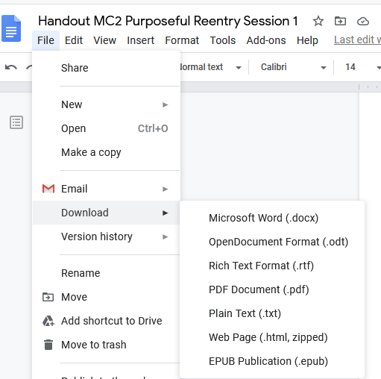

To make a copy, go to File, Make a Copy, and then rename the copied file. Your copy will be in your Shared With Me folder in your Google Drive.

To download it into another program, go to File, Download, and select the program you would like to use and then save it in that program.

